3G150B-How to limit the computer to access some websites by URL filter function?
Product line: 3G Question category: Function configarations

Q：Why we need to configure the URL Filtering?
A：In order to control the computer has access to websites. You can use URL Filtering to allow the computer to have access to certain websites at fixed time and forbids it having access to certain websites at fixed time.
Note: you only can set the URL Filtering when the 3G150B is in 3G Router mode or Router mode.

The Topology is as below:

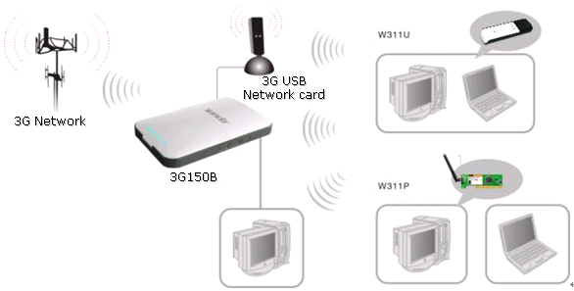
Steps are as below:
- Login to the management page of the router.
- Click the Security Settings→URL Filter. The URL filter is disable default.
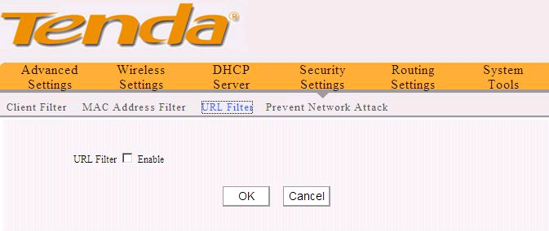
Tick Enable for the URL Filter
For example, you want to block the computers whose IP Address is 192.168.2.100 - 192.168.2.200 to access the websites that include “Google” from 8:00 am to 18:00 pm every day. And the computer with other IP address can access Internet. You can set the router following the picture as below.

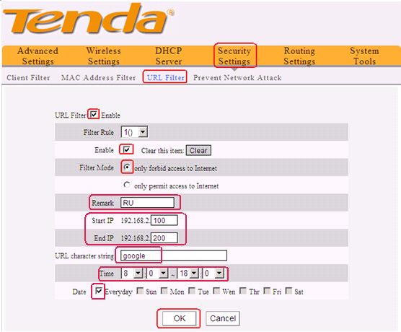
On the contrary, you only want to the computers with IP Address (192.168.2.100 - 192.168.2.200) can access the websites that include “Google” from 8:00 am to 18:00 pm every day and others can’t access the internet. You can set the router following the picture as below.
